

*Organisation: Solar Boat Sealander*

*Client: Mr. R. Eijlers*

*Tutor: Mr. W. Haak*

*Date: 17-01-2020*

System test plan

Propulsion system simulation

Fangzhou chen Jiacong li Marco Hoogesteger Martijn Crombeen

2020

Table of content

1. Aim & Hypothesis 2

1.1. Aim 2

1.2. Hypothesis 2

2. Variables 2

2.1. Inputs 2

2.2. Outputs 2

3. Tools 3

4. Method 3

4.1. Steps 3

5. Expected results 4

6. Conclusion 4

# Aim & Hypothesis

## Aim

The aim of this test is to verify the simulation of the propulsion system of the Solar boat.

## Hypothesis

The simulation will be verified according to the performed tests.

# Variables

These are the constants and variables that will be used during the test.

|  |  |
| --- | --- |
| Constants simulation | Keep constant at... |
| Ambient temperature | Standard indoor temperature with lower and upper limits (20 ℃ ± 5℃). |
| Battery level computer | Constant power source. |
| Software Excel | Newest version. |
| All input variables | Real positive numbers & ISO-notation. |
| Properties | Same as MAROF sheet. |

## Inputs

The limits stated are the limits of the real world. If values out of this range are entered, the outputs will be unreliable.

|  |  |
| --- | --- |
| Inputs | Value |
| Boat speed [m/s] | Change value between 0 & 8.3. |

## Outputs

These are the outputs that will be monitored and will be used to see variations or changes in the system.

|  |  |
| --- | --- |
| Outputs | Value |
| Thrust [N] | Indicator between 0 & 500 |
| Power input [W] | Indicator between 0 & 6000 |
| Power output [W] | Indicator between 0 & 4100 |
| Propellor speed [rpm] | Indicator between 0 & 620 |
| Prompts or warnings for successful or failed simulation | Simulate successfully / unsuccessfully |

# Tools

We divide the tools into two types. The first one is “testing tools” which are the tools requires to perform the test. The second one is “measuring tools”, which are the tools required to measure the given limits and properties.

|  |  |
| --- | --- |
| Testing tools | Demand |
| Computer | Windows 10 compatible |
| Excel | Newest version |
| Keyboard | No limit |
| Mouse | No limit |
| Calculator | Basic calculator |
| Pen & Paper | Basic pen & paper |

# Method

This section consists of actions that need to be performed during the test in order to conclude a result. The conditions of the constants stated in chapter “2. Variables” have to be met before executing the simulation. To execute the simulation, follow the steps stated in “4.1. Steps”.

To validate our design, we can compare it to the datasheet: “propdesign_algemen_sheet marof v3 HZ pr”. This is a datasheet with a lot of empirical data retrieved from testing and calculations based on that. This is performed by the MAROF, which is the study: Marine Officer. This data is carefully retrieved so we can use this data to validate our simulation.

The boat is not available for testing, so therefore we use data from a sheet instead of building a test setup and measuring data from that.

## Steps

1. Set up computer and load in simulation.
2. Insert measured motor input voltages and currents.
3. Run the simulation for each measurement.
4. Compare results with the corresponding outputs on the excel datasheet.

# Expected results

The expected results of the outputs are as followed.

For the output thrust, we expect the value to be between 0 and 500 [N].

For the power input, we expect the value to be between 0 and 6000 [W].

For the power output, we expect the value to be between 0 and 4100 [W].

For the propellor speed, we expect the value to be between 0 and 620 [rpm].

# Conclusion

When the input values are being changed within the given range, the output values are changing accordingly. We then consider the test as reliable and passed.

When the inputs are out of the given range but by no more than 10% of the range, the expected output values will be beyond the value range stated above. Then the output is considered as unreliable but the simulation is still working, so we consider that it passes the test.

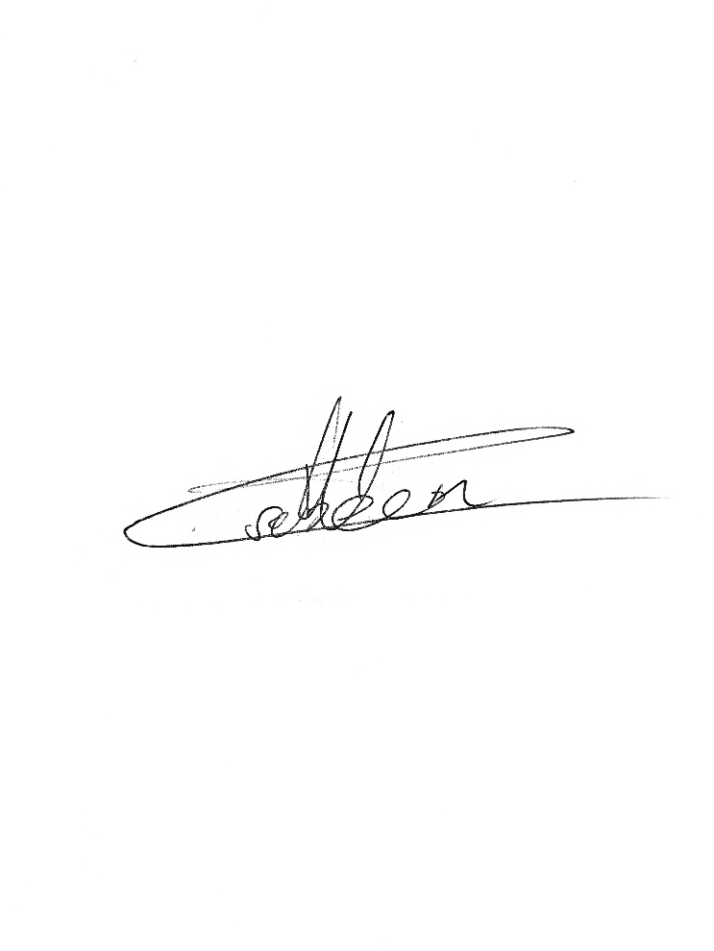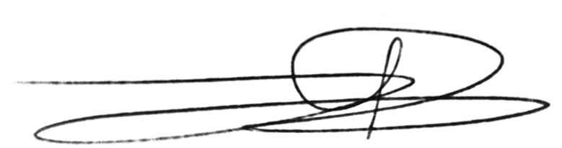Signed by group 1 Signed by Mr. Bardolf

Date: 16-10-2020 Date: 16-10-2020